**ε-greedy method on the 10-armed bandit problem**

Author(s): Anne Kunstmann (6651481), Alina Munir (7251819)

Submitted to: Dr. Víctor Uc Cetina

**Parameters:**

K_arms =10

Plays=1000

Iterations=2000

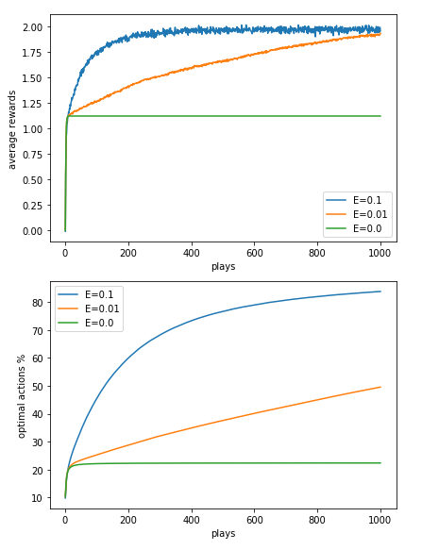

**Conclusion:**

For greedy method, average rewards instantly improved but almost quickly stabilized on a certain level without further improvement as it only exploited the already found value of estimated reward. On the other hand, ε-greedy method kept increasing the total rewards due to exploration property, the higher the exploration the quicker optimal results are found.